Report for ForestQuery into Global Deforestation, 1990 to 2016

ForestQuery is on a mission to combat deforestation around the world and to raise awareness about this topic and its impact on the environment. The data analysis team at ForestQuery has obtained data from the World Bank that includes forest area and total land area by country and year from 1990 to 2016, as well as a table of countries and the regions to which they belong.

The data analysis team has used SQL to bring these tables together and to query them in an effort to find areas of concern as well as areas that present an opportunity to learn from successes.

## 1. **GLOBAL SITUATION**

According to the World Bank, the total forest area of the world was **41,282,694 km 2** in 1990. As of 2016, the most recent year for which data was available, that number had fallen to **39,958,245.9 km2** a loss of **1,324,449 km2**, or 3.20 %.

The forest area lost over this time period is slightly more than the entire land area of **Peru** listed for the year 2016 (which is **1,279,999.9891 km2**).

## 2. **REGIONAL OUTLOOK**

In 2016, the percent of the total land area of the world designated as forest was **31.38%**. The region with the highest relative forestation was **Latin America & Caribbean**, with **46.16%**, and the region with the lowest relative forestation was **Middle East & North Africa**, with **2.07**% forestation.

In 1990, the percent of the total land area of the world designated as forest was **32.42%**. The region with the highest relative forestation was **Middle East & North Africa**, with **51.03%**, and the region with the lowest relative forestation was **Middle East & North Africa**, with **1.78%** forestation.

Table 2.1: Percent Forest Area by Region, 1990 & 2016:

|  |  |  |
| --- | --- | --- |
| Region | 1990 Forest Percentage | 2016 Forest Percentage |
| **East Asia & Pacific** | **25.78** | **26.36** |
| **Europe & Central Asia** | **37.28** | **38.04** |
| **Latin America &**  **Caribbean** | **51.03** | **46.16** |
| **Middle East & North**  **Africa** | **1.78** | **2.07** |
| **North America** | **36.65** | **36.04** |
| **South Asia** | **16.51** | **17.51** |
| **Sub-Saharan Africa** | **30.67** | **28.79** |

The only regions of the world that decreased in percent forest area from 1990 to 2016 were Latin **America & Caribbean** (dropped from **51.03%** to **46.16%**) and **Sub-Saharan**

**Africa** (**30.67%** to **28.79%).** All other regions actually increased in forest area over this time period. However, the drop in forest area in the two aforementioned regions was so large, the percent forest area of the world decreased over this time period from **32.42%** to **31.38%.**

## 3. **COUNTRY-LEVEL DETAIL**

### SUCCESS STORIES

There is one particularly bright spot in the data at the country level, **China.** This country actually increased in forest area from 1990 to 2016 by **527,229.662 km2**. It would be interesting to study what has changed in this country over this time to drive this figure in the data higher. The country with the next largest increase in forest area from 1990 to 2016 was the **United States**, but it only saw an increase of **79,200 km2**, much lower than the figure for **China**.

**China** and **United States** are of course very large countries in total land area, so when we look at the largest *percent* change in forest area from 1990 to 2016, we aren’t surprised to find a much smaller country listed at the top. **Iceland** increased in forest area by **213.66%** from 1990 to 2016.

### LARGEST CONCERNS

Which countries are seeing deforestation to the largest degree? We can answer this question in two ways. First, we can look at the absolute square kilometer decrease in forest area from 1990 to 2016. The following 3 countries had the largest decrease in forest area over the time period under consideration:

Table 3.1: Top 5 Amount Decrease in Forest Area by Country, 1990 & 2016:

|  |  |  |
| --- | --- | --- |
| Country | Region | Absolute Forest Area Change |
| **Brazil** | **Latin America &**  **Caribbean** | **541,510** |
| **Indonesia** | **East Asia & Pacific** | **282,193.9844** |
| **Myanmar** | **East Asia & Pacific** | **107,234.0039** |
| **Nigeria** | **Sub-Saharan Africa** | **106,506.0098** |
| **Tanzania** | **Sub-Saharan Africa** | **102,320** |

The second way to consider which countries are of concern is to analyze the data by percent decrease.

Table 3.2: Top 5 Percent Decrease in Forest Area by Country, 1990 & 2016:

|  |  |  |
| --- | --- | --- |
| Country | Region | Pct Forest Area Change |
| **Togo** | **Sub-Saharan Africa** | **75.45** |
| **Nigeria** | **Sub-Saharan Africa** | **61.80** |
| **Uganda** | **Sub-Saharan Africa** | **59.13** |
| **Mauritania** | **Sub-Saharan Africa** | **46.75** |
| **Honduras** | **Latin America &**  **Caribbean** | **45.03** |

When we consider countries that decreased in forest area percentage the most between 1990 and 2016, we find that four of the top 5 countries on the list are in the region of **Sub-Saharan**. The countries are **Togo**, **Nigeria**, **Uganda**, and **Mauritania**. The 5th country on the list is **Honduras**, which is in the **Latin America & Caribbean** region.

From the above analysis, we see that **Nigeria** is the only country that ranks in the top 5 both in terms of absolute square kilometer decrease in forest as well as percent decrease in forest area from 1990 to 2016. Therefore, this country has a significant opportunity ahead to stop the decline and hopefully spearhead remedial efforts.

### QUARTILES

Table 3.3: Count of Countries Grouped by Forestation Percent Quartiles, 2016:

|  |  |
| --- | --- |
| Quartile | Number of Countries |
| **First** | **85** |
| **Second** | **72** |
| **Third** | **38** |
| **Fourth** | **9** |

The largest number of countries in 2016 were found in the **First** quartile.

There were **94** countries in the top quartile in 2016. These are countries with a very high percentage of their land area designated as forest. The following is a list of countries and their respective forest land, denoted as a percentage.

Table 3.4: Top Quartile Countries, 2016:

90

|  |  |  |
| --- | --- | --- |
| Country | Region | Pct Designated as Forest |
| **Suriname** | **Latin America &**  **Caribbean** | **98.26** |
| **Micronesia, Fed. Sts.** | **East Asia & Pacific** | **91.86** |
| **Gabon** | **Sub-Saharan Africa** | **90.04** |
| **Seychelles** | **Sub-Saharan Africa** | **88.41** |
| **Palau** | **East Asia & Pacific** | **87.61** |
| **American Samoa** | **East Asia & Pacific** | **87.50** |
| **Guyana** | **Latin America &**  **Caribbean** | **83.90** |
| **Lao PDR** | **East Asia & Pacific** | **82.11** |
| **Solomon Islands** | **East Asia & Pacific** | **77.86** |

## 4. RECOMMENDATIONS

*Write out a set of recommendations as an analyst on the ForestQuery team.*

* *What have you learned from the World Bank data?*

*1. Global Deforestation Trend:*

*- The world's total forest area decreased by 3.20% from 1990 to 2016.*

*- While five out of seven regions experienced an increase in forest area during this period, Latin America & Caribbean and Sub-Saharan Africa saw a decline in their forest cover.*

*- The data reveals that smaller countries with a smaller total land area tend to have a higher percentage of forest land.*

*2. Regional Variation:*

*- Regions like East Asia & Pacific, Europe & Central Asia, and North America demonstrated success in increasing their forest area from 1990 to 2016.*

*- Latin America & Caribbean and Sub-Saharan Africa faced significant challenges in preserving their forests, warranting targeted interventions in these regions.*

*3. Focus on High-Deforestation Countries:*

*- Countries like Brazil, Indonesia, Myanmar, Nigeria, Tanzania, Togo, Uganda, Mauritania, and Honduras experienced substantial forest area losses, either in terms of absolute forest area or percentage forest land.*

*- Nigeria emerges as a particularly critical concern, being in the top 5 for both absolute forest area loss and percentage decrease in forest area.*

*4. Learn from Successful Cases:*

*- China stands out as a notable success story, showing a substantial increase in forest area from 1990 to 2016. Investigating the policies and strategies that contributed to China's success could provide valuable insights for other countries.*

*Overall, the World Bank data highlights the importance of targeted interventions to address deforestation in specific regions and countries. The success stories and concerning cases offer valuable lessons to develop effective strategies to combat deforestation and promote sustainable forest management practices. By focusing on high-deforestation areas and collaborating with international partners, ForestQuery can make significant strides in its mission to combat global deforestation and protect the world's forests.*

* *Which countries should we focus on over others?*

*As an analyst on the ForestQuery team, the data analysis points to several countries that should be prioritized for focused efforts and interventions to combat deforestation and promote sustainable forest management. These countries have experienced significant forest area losses, either in terms of absolute forest area or percentage forest land. Here are the countries that warrant closer attention:*

*1Brazil - Brazil experienced the largest absolute forest area loss of 541,510 km2 from 1990 to 2016, making it a significant concern for deforestation.*

*2. Indonesia:*

*- Indonesia follows closely with an absolute forest area loss of 282,193.9844 km2 over the same period, indicating the urgency to address deforestation challenges in the country.*

*3. Myanmar:*

*- Myanmar faced a considerable absolute forest area loss of 107,234.0039 km2, emphasizing the need for targeted measures to conserve forests.*

*4. Nigeria:*

*- Nigeria not only experienced a substantial absolute forest area loss of 106,506.0098 km2 but also witnessed a high percentage decrease in forest area (61.80%), making it a country of particular concern.*

*5. Tanzania:*

*- Tanzania recorded a significant absolute forest area loss of 102,320 km2, indicating the importance of addressing deforestation challenges in the country.*

*6. Togo:*

*- Togo stands out with the largest percentage decrease in forest area (75.45%) from 1990 to 2016, warranting immediate attention to understand and address the drivers of deforestation.*

*7. Uganda:*

*- Uganda faced a considerable percentage decrease in forest area (59.13%), making it another country that requires focused efforts to combat deforestation.*

*8. Mauritania:*

*- Mauritania experienced a notable percentage decrease in forest area (46.75%), making it important to understand the factors leading to forest loss and implement remedial measures.*

*9. Honduras:*

*- Honduras rounds up the list with a substantial percentage decrease in forest area (45.03%), highlighting the need for targeted interventions in the Latin America & Caribbean region.*

*By focusing on these countries, ForestQuery can direct its efforts towards understanding the drivers of deforestation, engaging with local stakeholders, and implementing targeted strategies to conserve and restore forests. Collaboration with international partners, sharing best practices, and supporting reforestation initiatives in these high-priority countries can make a significant impact in the mission to combat deforestation and promote sustainable forest management globally.*

## 5. APPENDIX: SQL Queries Used

CREATE VIEW forestation AS  
SELECT DISTINCT  
 f.country_code AS country_code,  
 f.country_name AS country_name,  
 f.year AS year,  
 f.forest_area_sqkm,  
 (l.total_area_sq_mi * 2.59) AS total_area_sqkm,  
 r.region,  
 r.income_group,  
 100 * (f.forest_area_sqkm / (l.total_area_sq_mi * 2.59)) AS forest_percent_of_land  
FROM forest_area f  
JOIN land_area l ON f.country_code = l.country_code AND f.year = l.year  
JOIN regions r ON f.country_code = r.country_code;

**Question 1:** What was the total forest area (in sq km) of the world in 1990? Please keep in mind that you can use the country record denoted as “World” in the region table.

SELECT *  
FROM forestation  
WHERE year = 1990 AND country_name = 'World' ;

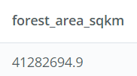

**Question 2:** What was the total forest area (in sq km) of the world in 2016? Please keep in mind that you can use the country record in the table is denoted as “World.”

SELECT *  
FROM forestation  
WHERE year = 2016 AND country_name = 'World';

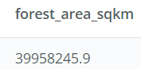

**Question 3:** What was the change (in sq km) in the forest area of the world from 1990 to 2016?

SELECT forest_area_sqkm - (  
 SELECT forest_area_sqkm  
 FROM forestation  
 WHERE year = 2016 AND country_name = 'World'  
) AS forest_area_change  
FROM forestation  
WHERE year = 1990 AND country_name = 'World';

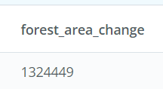

**Question 4:** What was the percent change in forest area of the world between 1990 and 2016?

SELECT  
 forest_area_sqkm,  
 year,  
 ((forest_area_sqkm - LEAD(forest_area_sqkm, 1) OVER (ORDER BY year)) / forest_area_sqkm) * 100  
 AS percent_change_in_forest_area  
FROM  
 (  
 SELECT  
 forest_area_sqkm,  
 year,  
 country_name  
 FROM  
 forestation  
 WHERE  
 year IN ('1990', '2016')  
 AND country_code = 'WLD'  
 ) AS sub;

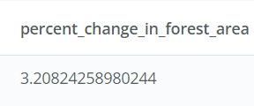

**Question 5:** If you compare the amount of forest area lost between 1990 and 2016, to which country’s total area in 2016 is it closest to?

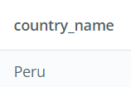

### Part 2— Regional Outlook

**Instructions:**

* Answering these questions will help you add information into the template.
* Use these questions as guides to write SQL queries.
* Use the output from the query to answer these questions.
* Create a table that shows the Regions and their percent forest area (sum of forest area divided by the sum of land area) in 1990 and 2016. (Note that 1 sq mi = 2.59 sq km.)  
  Based on the table you created,..

CREATE VIEW regional_outlook AS  
SELECT  
 f.region,  
 f.year,  
 ROUND(  
 CAST(100 * (SUM(f.forest_area_sqkm) / SUM(l.total_area_sq_mi * 2.59)) AS NUMERIC),  
 2  
 ) AS total_forest_percent  
FROM  
 forestation f  
JOIN  
 land_area l ON f.country_code = l.country_code AND f.year = l.year  
WHERE  
 f.year IN (1990, 2016)  
GROUP BY  
 f.region,  
 f.year  
ORDER BY  
 total_forest_percent;

**Question 1:**

**Part a:** What was the percent forest of the entire world in 2016?

SELECT total_forest_percent  
FROM regional_outlook  
WHERE year = 2016 AND region = 'World';

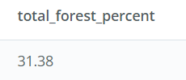

**Part b:** Which region had the HIGHEST percent forest in 2016, and which had the LOWEST, to 2 decimal places?

-- Highest  
SELECT *  
FROM regional_outlook  
WHERE year = 2016 AND region != 'World'  
ORDER BY total_forest_percent DESC  
LIMIT 1;

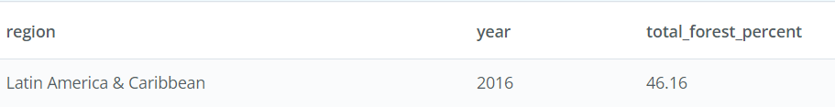

-- Lowest  
SELECT *  
FROM regional_outlook  
WHERE year = 2016 AND region != 'World'  
ORDER BY total_forest_percent  
LIMIT 1;

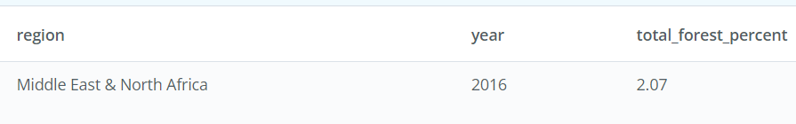

**Question 2:**

**Part a:** What was the percent forest of the entire world in 1990?

SELECT total_forest_percent  
FROM regional_outlook  
WHERE year = 1990 AND region = 'World';

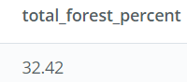

**Part b:** Which region had the HIGHEST percent forest in 1990, and which had the LOWEST, to 2 decimal places?

-- Highest  
SELECT *  
FROM regional_outlook  
WHERE year = 1990 AND region != 'World'  
ORDER BY total_forest_percent DESC  
LIMIT 1

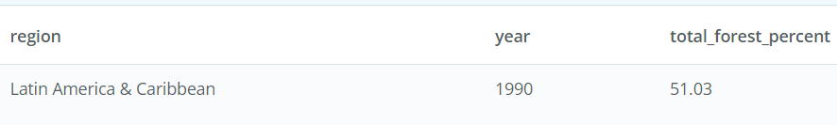

-- Lowest  
SELECT *  
FROM regional_outlook  
WHERE year = 1990 AND region != 'World'  
ORDER BY total_forest_percent  
LIMIT 1;

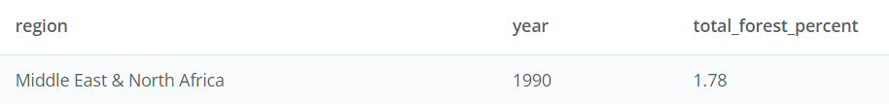

**Question 3:** Based on the table you created, which regions of the world DECREASED in forest area from 1990 to 2016?

SELECT sub.region, sub.year, sub.forest_change,  
CASE WHEN sub.forest_change > 0  
THEN 'Increased'  
ELSE 'Decreased'  
END  
AS forest_increased_or_decreased  
FROM ( SELECT region, year, total_forest_percent,  
(total_forest_percent - ( LEAD (total_forest_percent,1)  
OVER (PARTITION BY region ORDER BY year DESC)))  
AS forest_change  
FROM regional_outlook  
WHERE year = 1990 OR year = 2016  
) AS sub  
WHERE year = 2016

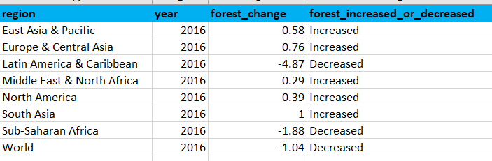

### Part 2- Country-Level Detail

Instructions:

* Answering these questions will help you add information to the template.
* Use these questions as guides to write SQL queries.
* Use the output from the query to answer these questions.

/**** VIEW for COUNTRY-LEVEL Details *****/  
CREATE VIEW country_level_detail AS  
SELECT DISTINCT  
 ft1.country_name,  
 ft1.region,  
 ft1.forest_area_sqkm AS forest_area_sqkm_2016,  
 ft2.forest_area_sqkm AS forest_area_sqkm_1990,  
 (ft1.forest_area_sqkm - ft2.forest_area_sqkm) AS Forest_area_sqkm_change_2016_vs_1990,  
 ROUND(100 * CAST((ft1.forest_area_sqkm - ft2.forest_area_sqkm) / ft2.forest_area_sqkm AS NUMERIC), 2) AS forest_percent_1990_vs_2016  
FROM  
 forestation ft1,  
 forestation ft2  
WHERE  
 (ft1.year = '2016' AND ft2.year = '1990')  
 AND (ft1.country_code = ft2.country_code);

/**** Top two countries which increased its forest area the most *****/  
SELECT *  
FROM country_level_detail  
WHERE country_name != 'World' AND  
 (forest_area_sqkm_change_2016_vs_1990 > 0)  
ORDER BY forest_area_sqkm_change_2016_vs_1990 DESC  
LIMIT 2;



/**** The country that has the largest percent change in forest area  
from 1990 to 2016 *****/  
SELECT *  
FROM country_level_detail  
WHERE country_name != 'World'  
 AND forest_percent_1990_vs_2016 > 0  
ORDER BY forest_percent_1990_vs_2016 DESC  
LIMIT 1;

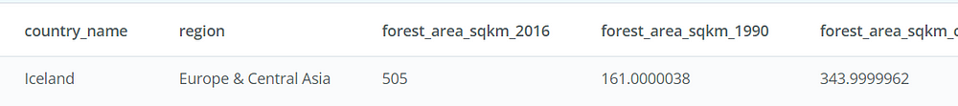

**Question 1:** Which 5 countries saw the largest amount decrease in forest area from 1990 to 2016? What was the difference in forest area for each?

SELECT country_name,  
 region,  
 forest_area_sqkm_change_2016_vs_1990  
FROM country_level_detail  
WHERE country_name != 'World'  
 AND forest_area_sqkm_change_2016_vs_1990 IS NOT NULL  
ORDER BY forest_area_sqkm_change_2016_vs_1990 DESC  
LIMIT 5;

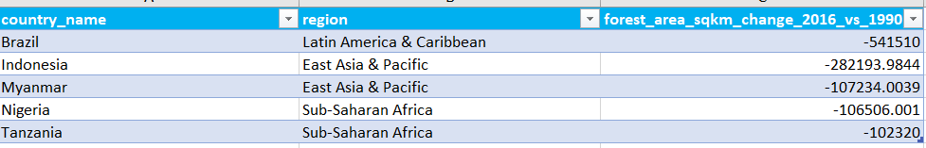

**Question 2:** Which 5 countries saw the largest percent decrease in forest area from 1990 to 2016? What was the percent change to 2 decimal places for each?

SELECT country_name,  
 region,  
 ROUND(forest_percent_1990_vs_2016, 2)  
FROM country_level_detail  
WHERE country_name != 'World'  
 AND forest_percent_1990_vs_2016 IS NOT NULL  
ORDER BY forest_percent_1990_vs_2016 DESC  
LIMIT 5;

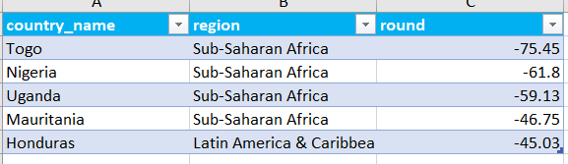

**Question 3:** If countries were grouped by percent forestation in quartiles, which group had the most countries in it in 2016?

SELECT COUNT(country_name),  
 CASE  
 WHEN forest_percent_of_land <= 25 THEN 'FIRST'  
 WHEN forest_percent_of_land BETWEEN 25 AND 50 THEN 'SECOND'  
 WHEN forest_percent_of_land BETWEEN 50 AND 75 THEN 'THIRD'  
 WHEN forest_percent_of_land > 75 THEN 'FOURTH'  
 END AS forest_percent_quartile  
FROM forestation  
WHERE country_name != 'World' AND year = 2016 AND forest_percent_of_land IS NOT NULL  
GROUP BY forest_percent_quartile;

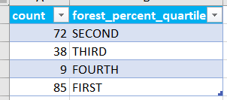

**Question 4:** List all of the countries that were in the 4th quartile (percent forest > 75%) in 2016.

SELECT country_name,  
 region,  
 ROUND(CAST(forest_percent_of_land AS NUMERIC), 2) AS forest_percent  
FROM forestation  
WHERE country_name != 'World'  
 AND year = 2016  
 AND forest_percent_of_land > 75  
ORDER BY forest_percent_of_land DESC;

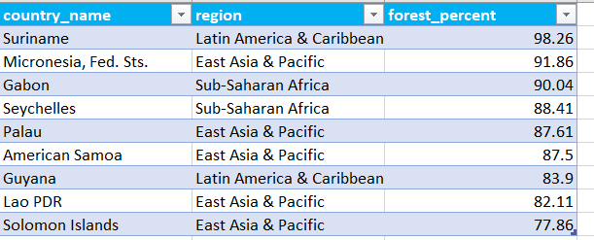

**Question 5:** How many countries had a percent forestation higher than the United States in 2016?

WITH T1 AS (  
 SELECT forest_percent_of_land  
 FROM forestation  
 WHERE country_name LIKE 'United States'  
 AND year = 2016  
)  
SELECT COUNT(country_name)  
FROM T1, forestation AS f  
WHERE f.forest_percent_of_land > T1.forest_percent_of_land  
AND f.year = 201;

